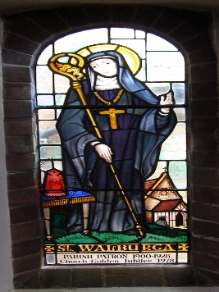
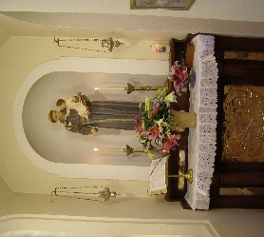
Saint Anthony of Padua Catholic Church
{formerly Saint Walburga, Abbess}
Rye, East Sussex
“At the Top of the Town”
“The Greyfriars” since AD 1910
“Jesus came to you, so that you can come to Him”
The Arundel & Brighton Diocesan Trust (a Fairtrade Diocese)
is a Registered Charity: 252878

The Parish The Franciscans (The Greyfriars)
Franciscan Friary The Greyfriars: www.thegreyfriars.org
Watchbell Street St. Anthony of Padua, Rye:
Rye, East Sussex, TN31 7HB www.thegreyfriars.org/rye-east-sussex
01797 222 173 (Friary/Parish phone) The Secular Franciscan Order in GB: http://ofsgb.org
Email: catholicparish.rye@gmail.com Saint Clare Fraternity, Poor Clare Convent, Hollington,
Parish web site: https://stanthonyrye.com meets on the 1st Sunday of the month. Pat Lee, minister,
Diocese of Arundel & Brighton: e-mail: sueandpatlee7@tiscali.co.uk
http://www.dabnet.org/ Rye St. Antony School: https://www.ryestantony.co.uk/

Society for the Protection of Unborn Children: Home (spuc.org.uk) or 020 7091 7091

Poor Clares’ Prayer Line-Text names to:
07871 732 792

Fr. Matthew Chadwick, OFM Conv., Parish Priest
Rev. Mr. Simon South, Deacon

6 JUNE 2022 ~ PENTECOST SUNDAY
“If you love Me, you will keep My Commandments”

Times of Mass This Week
4 June Saturday + Ann Hamilton, req. Teresa Brooks 6:00 PM PENTECOST SUNDAY
5 June Sunday For the Parishioners 8:00 AM PENTECOST SUNDAY
5 June Sunday Intentions on the St. Anthony Board 10:45 AM PENTECOST SUNDAY
6 June Monday + Derek Sykes (FMA) 9:00 AM Mary, Mother of the Church
7 June Tuesday Rose Fitzgibbon (FMA) 9:00 AM St. Willibald, Bishop of Eichstatt,
brother of St. Walburga
8 June Wednesday Lily (FMA) 9:00 AM St. Edgar the Peaceful, English king
9 June Thursday + Maria Stephenson (FMA) 9:00 AM Our Lord Jesus Christ, Eternal High Priest
10 June Friday + Michelle Stephenson (FMA) 9:00 AM St. Ithamar,1st Anglo-Saxon bishop in Britain
11 June Saturday Jane Beever (FMA) 9:00 AM Blessed Virgin Mary on Saturday
11 June Saturday + Sheila O’Connor (FMA) 6:00 PM MOST HOLY TRINITY SUNDAY
12 June Sunday In Thanksgiving, req. Ledes Duffy 8:00 AM MOST HOLY TRINITY SUNDAY
12 June Sunday For the Parishioners 10:45 AM MOST HOLY TRINITY SUNDAY

PLEASE PRAY FOR THE DECEASED, ESPECIALLY Members of our parish, our families, our relatives, our friends, our acquaintances, those who die suddenly or violently, especially during war or unrest, and Mass intentions for this week.

PLEASE PRAY FOR THE FOLLOWING PERSONS: Sheila Miller [She fell in her home, no broken bones, only bruises, now with her daughter in Bexhill for a few weeks), Ron Peters, Audrey Hatter, Vickie Hatter (now both in Roseland Care Home), Fr. Paul Clarke, John Wakely, Ita & Bob Bligh, Susan Clarke, Kathleen Sherwood, Monica Flint, Richard Horner, Janet (Jane) Castro, all those confined to their homes or care homes, my nephew, Nathaniel, and Mass intentions this week.

- THE FEAST OF ST. ANTHONY OF PADUA IS BACK!
The Annual Parish Lunch to celebrate the Feast Day of St. Anthony of Padua will be at Simply Italian on Monday 13th June at 12.30 pm. We hope as many parishioners as possible will attend. Form and details are at back of church.
+++++++++++++++++++++++++++++++++++++++++++++++++++++++++++++++
- SCRIPTURE DISCUSSION THIS WEEK, Monday, 6 June, 2022.
**************************************************************************
REAL TIME: (958) Real Time: Episode 21 (20/05/2022) - YouTube
MARCH FOR LIFE UK, LONGDON: SATURDAY 3 SEPTEMBER 2022
MASS: 11:00 AM, St. George’s Cathedral Southwark
MARCH: 2:00 PM FROM THE EMMANUEL CENTRE
ENDS AT PARLIAMENT SQUARE, 4:30 PM.
JOIN US IN SAYING: 10 MILLION TOO MANY!
=======================================================================================
St. Willibald was a bishop and missionary. A native of Wessex, England, he was the brother of Ss. Winebald and Walburga and was related through his mother to the great St. Boniface. After studying in a monastery in Waitham, in Hampshire, he went on a pilgrimage to Rome (c. 722) with his father, who died on the way at Lucca, Italy. Willibald continued on to Rome and then to Jerusalem. Captured by Saracens who thought him a spy, he was eventually released and continued on to all of the holy places and then to Constantinople (modern Istanbul, Turkey), where he visited numerous lauras, monasteries, and hermitages. Upon his return to Italy, he went to Monte Cassino where he stayed for ten years, serving as sacrist, dean, and porter. While on a visit to Rome, he met Pope St. Gregory III (r. 731-741), who sent him to Germany to assist his cousin St. Boniface in his important missionary endeavors. Boniface ordained him in 741 and soon appointed him bishop of Eichstatt, in Franconia. the Site of Willibald's most successful efforts as a missionary. With his brother Winebald, he founded a double monastery at Heidenheim, naming Winebald abbot and his sister Walburga abbess. Willibald served as bishop for some four decades. His Vita is included in the Hodoeporicon (the earliest known English travel book). An account of his journeys in the Holy Land was written by a relative of Willibald and a nun of Heidenheim. St. Willibald - Saints & Angels - Catholic Online
============================================================================FROM BISHOP RICHARD: Bishop Richard’s Pentecost Podcast on Vimeo

Dear brothers and sisters,
We rejoice this Sunday as we celebrate the coming of the Holy Spirit upon the young Church – the Apostles gathered in the Upper Room. The coming of the Holy Spirit transforms their lives. No longer do they remain locked in the room together, fearful for their lives. They go out to proclaim the message of the Risen Christ.
So with us, who have received the Holy Spirit at our baptism and confirmation. We can be fearless in announcing the Good News in our present, often darkened, world. Into the difficulties, struggles and sorrows of the world, the Lord Himself calls us to take His message, our every step guided by the Spirit, our every word given us by the Spirit.
This Pentecost, let us hear the call to return to the fulfilment of our Sunday Observance together as parish communities. This is an obligation of love. When we reflect on all that the Lord has done for us – His birth for us, His Passion and death for us, His Resurrection for us, the sending of the Spirit for us, the gift of the Eucharist for us – there can be only one response on our part. This is the response of love, of worship together with our brothers and sisters. It is keeping holy, the Day of the Lord.
As the Apostles left the Upper Room to preach the Word, so we leave the celebration of Mass, strengthened by the Bread of Life, the Lord Himself and heading the last words of the celebration: go and announce the Gospel of the Lord.
With every Blessing,

+ Richard

“To conquer the whole world for Christ through Mary Immaculate”
Militia Immaculatae [MI}: Militia of the Immaculata – Official Website of the Militia of the Immaculata USA The MI in the UK: Home (mi-sheffield.com)

The Conversion of Alphonse Ratisbonne
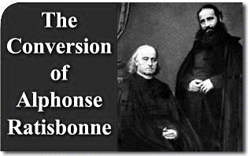
November 2, 2015 | Armando
Alphonse Ratisbonne was a young Jew from a family of well-established bankers in Strasbourg, France. He also was socially prominent due to his wealth and blood-ties to the Rothschild.
In 1827, Alphonse’s older brother, Thèodore, converted to Catholicism and entered the priesthood, thus breaking with his family whose hopes now lay in the young Alphonse, born in 1814.
Alphonse was intelligent and well mannered, had already finished his law degree and was engaged to a young Jewess, his niece. He was twenty-seven years old and, before marrying, he wanted to travel on holiday to Italy and the East. Upon his return, he planned to marry and take on his responsibilities in his family’s banking business.
God, however, had other plans for him in Rome.
Alphonse was not a practicing Jew. He nourished a profound hatred for the Catholic Church, especially because of the resentment his whole family had due to their first-born’s defection. Alphonse said he would never change religion. But if one day he were to change, he would become a Protestant, never a Catholic.
While in Rome, Ratisbonne visited works of art, as well as some Catholic churches, out of cultural curiosity. These visits hardened his anti-Catholic stance.
He also visited an old schoolmate and close friend named Gustave de Bussières. Gustave was a Protestant and several times had tried, in vain, to win Alphonse over to his religious convictions. In Gustave’s house, Alphonse was introduced to Gustave’s brother, Baron Thèodore de Bussières, who had just recently converted to Catholicism. Baron Thèodore, in turn, was a close friend of Father Thèodore Ratisbonne. Because of these two circumstances, Alphonse greatly disliked him.
Thus it was only on the eve of his departure that he reluctantly resolved to fulfill his social obligation to leave his calling card at the Baron’s house as a farewell gesture.
Hoping to avoid a meeting, Alphonse intended to leave his card discreetly and depart straight away. The Baron’s Italian servant, however, did not understand his French and showed him into the parlor while he went to call the Baron. The latter greeted the young Jew and immediately established cordial relations, while trying to attract him to the Catholic Faith.
With much insistence, he was able to persuade Alphonse to delay his departure from Rome in order to attend a ceremony to be held at Saint Peter’s Basilica. He further succeeded in persuading Ratisbonne to accept a Miraculous Medal and to promise to copy down a very beautiful prayer: the Memorare. Had this not been inspired by grace, it would have been utterly indiscreet.
The Jew could hardly contain his anger at the Baron’s boldness of proposing these things to him, but decided to take everything good-heartedly, hoping, as he later declared, to write a book about his travels. In this book, the Baron would appear as nothing more than an eccentric man.
On January 18, a close friend of the Baron de Bussières died. He was Count de La Ferronays, the former French ambassador to the Holy See and a man of great virtue and piety. On the eve of his sudden death, La Ferronays was talking to Bussières about Ratisbonne and, at the request of Bussières, prayed the Memorare one hundred times for his conversion. It is even possible that he offered his life to God for the conversion of the young banker.
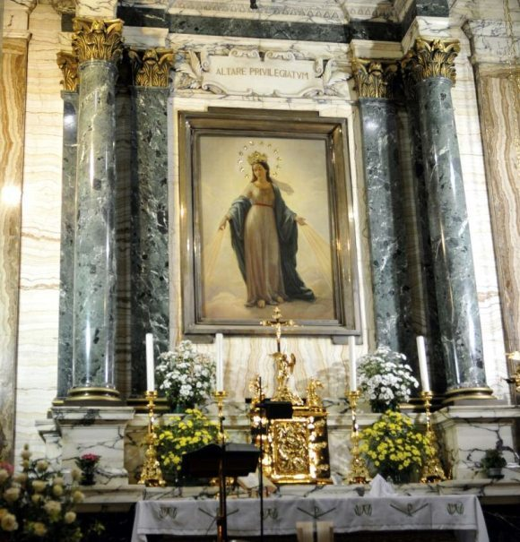
Around midday on January 20, the Baron de Bussières went to the church of Sant’Andrea delle Fratte to arrange for his deceased friend’s funeral to be held the following day. Ratisbonne reluctantly went along making violent criticisms of the Church and mocking Catholic practices. When they arrived at the church, the Baron left him alone for a few minutes and entered the sacristy to see about the funeral arrangements. Alphonse decided to look around and went up one of the side aisles since he could not cross over due to the preparations for the Count’s funeral in the central nave.
When the Baron returned just a few minutes later, he did not find Alphonse where he had left him. After much searching, he found him on the other side of the Church kneeling close to an altar, weeping. He no longer found a Jew, but a convert who ardently desired baptism.
Ratisbonne himself tells us what happened in those few minutes: “I had only been in the church a short while when, all of a sudden, I felt totally uneasy for no apparent reason. I raised my eyes and saw that the whole building had disappeared. Only one side chapel had, so to say, gathered all the light. In the midst of this splendor, the Virgin Mary appeared standing on the altar. She was grandiose, brilliant, full of majesty and sweetness, just as she is in the Miraculous Medal. An irresistible force attracted me to her. The Virgin
Madonna del Miracolo side altar of the Church of Saint
Andrea delle Fratte where Alphonse Ratisbonne
converted to Catholicism.

made a gesture with her hand indicating I was to kneel and as if saying ‘very good!’ Although she did not say anything, I understood everything.”
Ratisbonne never could explain how, being in one of the lateral naves before the apparition, he was found in the other, since the central nave was obstructed. However, in face of the magnitude of the miracle of his conversion, this was but a detail.
The news of such an unexpected conversion, so fulminating and complete, immediately spread and caused a great commotion throughout Europe.
Pope Gregory XVI wished to meet the young convert and received him paternally. He ordered a detailed investigation with all the rigor required by canon law. The conclusion was that it was truly an authentic miracle.
Having taken the name Maria Alphonse at baptism, Ratisbonne wished to become a Jesuit and was ordained in 1847. After a while and at the suggestion of Blessed Pope Pius IX, he left the Jesuits and joined his brother Thèodore in founding the Congregation of Our Lady of Sion, dedicated to the conversion of the Jews.
Father Theodore spread his congregation throughout France and England, while Father Maria Alphonse went to the Holy Land. In Jerusalem he bought a plot of land where the praetorium of Pilate had formerly stood. Here he established a house of the congregation. The two brothers died in 1884, both with the fame of exceptional virtues.

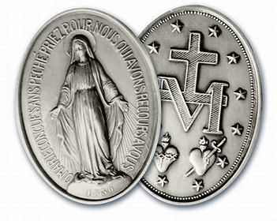
O Mary conceived without sin,

pray for us who have recourse to thee,

and all those who do not have

recourse to thee,

especially enemies of Holy Church

and those recommended to thee!

